**Project 1**

**Question 1**

1. The root-mean-square error (RMSE) of my estimated image. 20,000 steps.

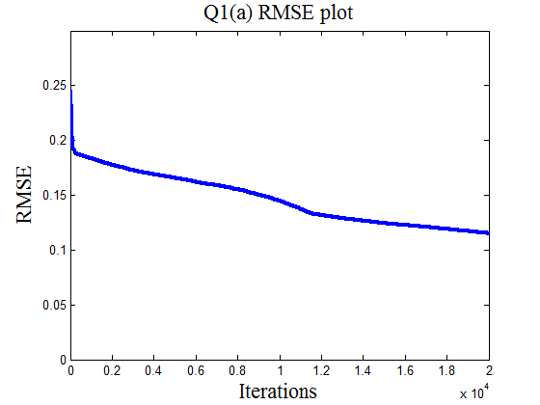

1. (1) I required Matlab to randomly choose a row of matrix H in each iteration step for the ART algorithm. (2) In this method, the iterated function was projected onto an uncorrelated basis with respect to the basis in the previous iteration step. (3) The convergence rate was better than what I obtained in part (a). The plot of RMSE is shown below.

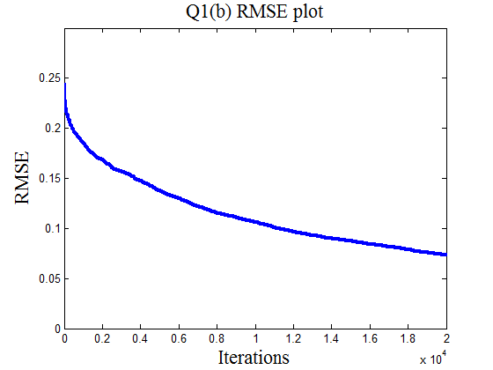

1. Image reconstruction without noise Image reconstruction with noise

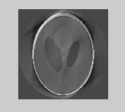 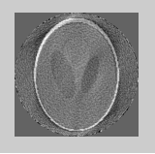

The plot of RMSE

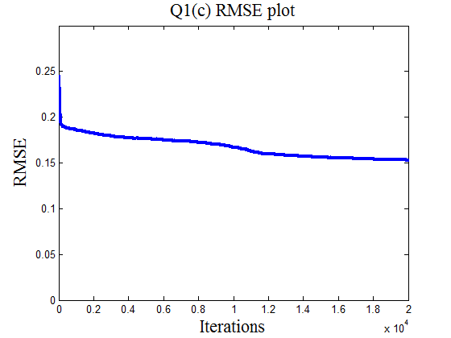

Some tiny objects disappear, and a lot of ripple appears in the image, if Gaussian white noise is added to the g1. The convergence rate is also slower than that in part (a).

**Question 2**

Image reconstruction using the algorithm in question 1 part (b)

